HTML Style Guide
# Source: AI Source: Provided by: [Data Path: Persons Table -> ID Column: 1, Name_En Column: Motasem Essam] -> From: [ChatGPT] on [5/6/2026]
An HTML Style Guide is a set of rules and best practices for writing clean, readable, and consistent HTML code. It helps developers write code that is easy to understand, maintain, and work on in teams.

🧱 Why HTML style guides are used
# Source: AI Source: Provided by: [Data Path: Persons Table -> ID Column: 1, Name_En Column: Motasem Essam] -> From: [ChatGPT] on [5/6/2026]
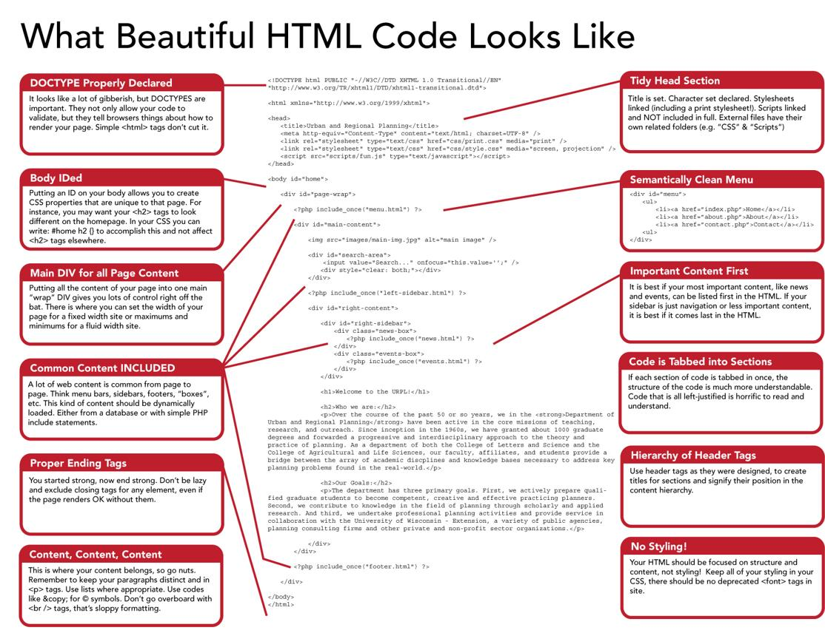
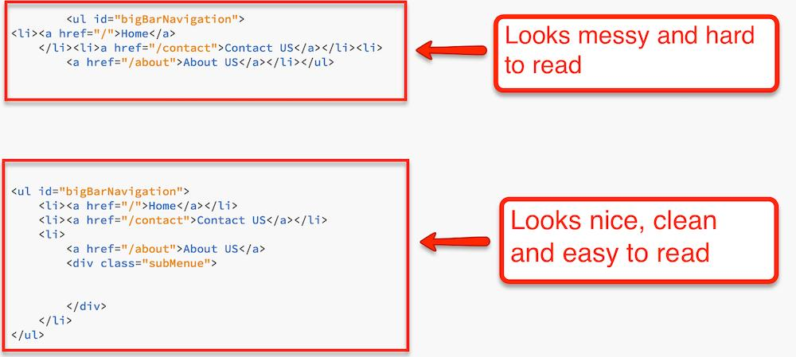
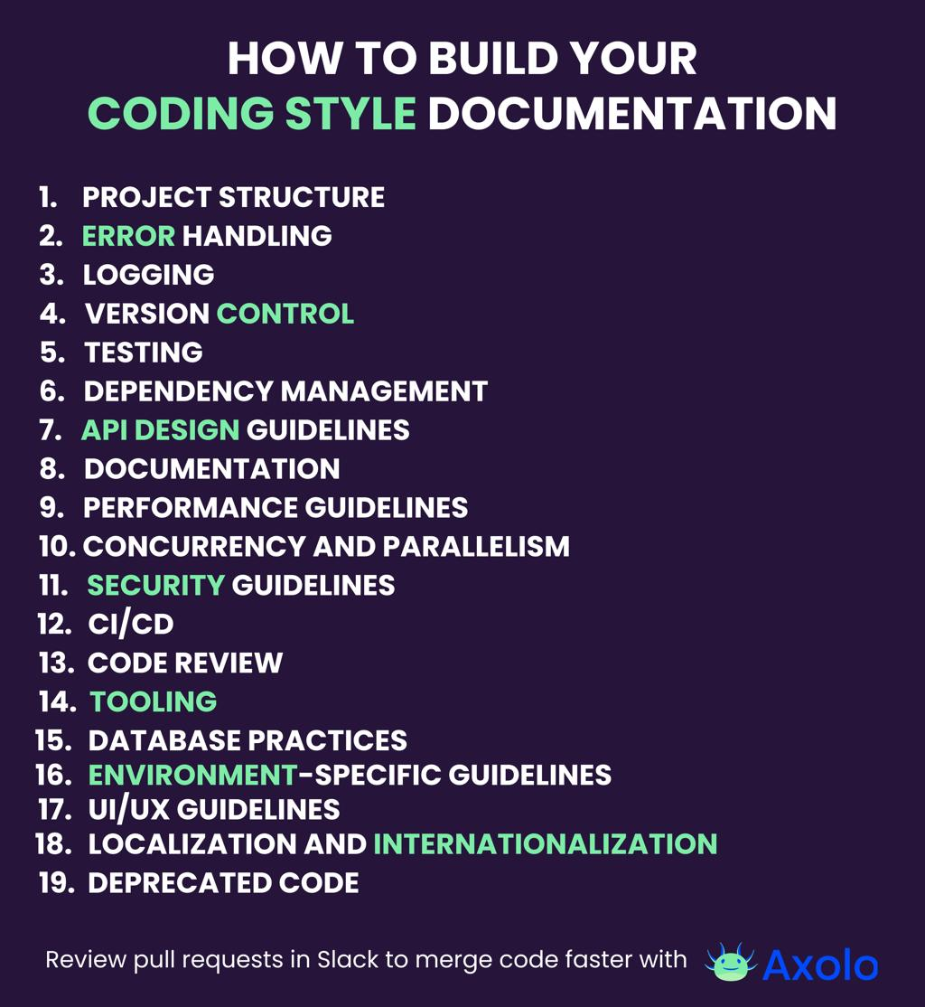
- 📖 Makes code easy to read
- 🧑‍💻 Helps teams work together
- 🐞 Reduces errors and bugs
- 🔧 Makes code easier to maintain

✏️ Common HTML Style Rules

1. 🧱 Indentation
# Source: AI Source: Provided by: [Data Path: Persons Table -> ID Column: 1, Name_En Column: Motasem Essam] -> From: [ChatGPT] on [5/6/2026]
📖 Description:
Indentation shows structure (parent → child). Without it, code becomes hard to read.
❌ Bad:
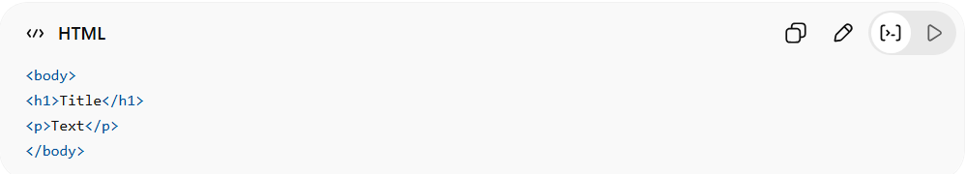
<body>
<h1>Title</h1>
<p>Text</p>
</body>
✅ Good:
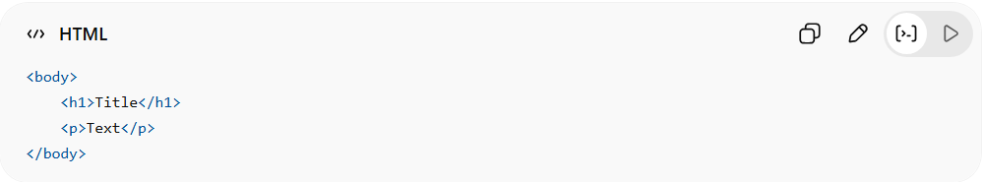
<body>
<h1>Title</h1>
<p>Text</p>
</body>

2. 🔤 Lowercase Tags
# Source: AI Source: Provided by: [Data Path: Persons Table -> ID Column: 1, Name_En Column: Motasem Essam] -> From: [ChatGPT] on [5/6/2026]
📖 Description:
HTML tags should always be lowercase for consistency.
❌ Bad:
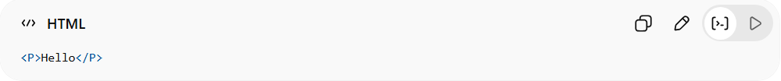
<P>Hello</P>
✅ Good:
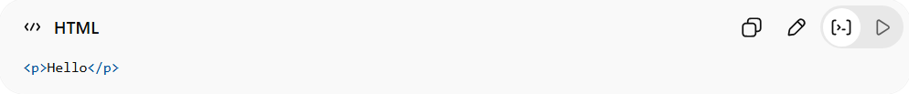
<p>Hello</p>

3. 🔒 Closing Tags
# Source: AI Source: Provided by: [Data Path: Persons Table -> ID Column: 1, Name_En Column: Motasem Essam] -> From: [ChatGPT] on [5/6/2026]
📖 Description:
Always close tags properly to avoid broken layouts.
❌ Bad:
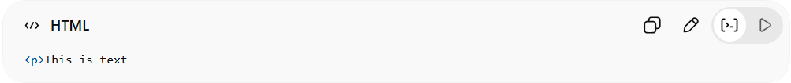
<p>This is text
✅ Good:
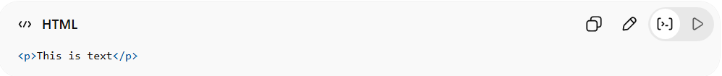
<p>This is text</p>

4. 🧩 Semantic Tags
# Source: AI Source: Provided by: [Data Path: Persons Table -> ID Column: 1, Name_En Column: Motasem Essam] -> From: [ChatGPT] on [5/6/2026]
📖 Description:
Use meaningful tags instead of generic <div> everywhere.
❌ Bad:
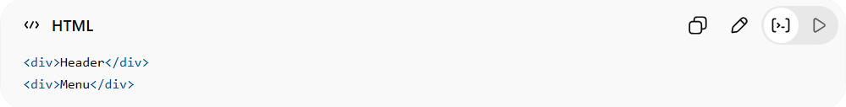
<div>Header</div>
<div>Menu</div>
✅ Good:
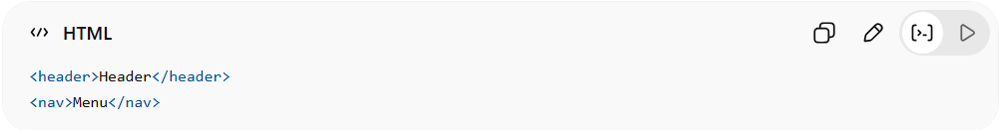
<header>Header</header>
<nav>Menu</nav>

5. 🏷️ Meaningful Names
# Source: AI Source: Provided by: [Data Path: Persons Table -> ID Column: 1, Name_En Column: Motasem Essam] -> From: [ChatGPT] on [5/6/2026]
📖 Description:
Class and ID names should describe their purpose.
❌ Bad:
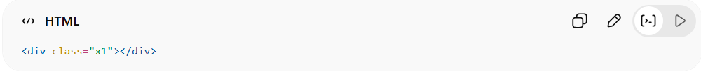
<div class="x1"></div>
✅ Good:
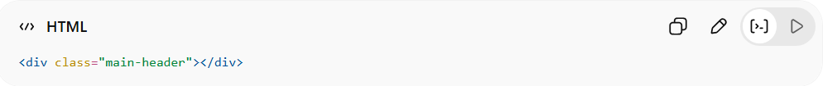
<div class="main-header"></div>

6. 🔗 Quotes for Attributes
# Source: AI Source: Provided by: [Data Path: Persons Table -> ID Column: 1, Name_En Column: Motasem Essam] -> From: [ChatGPT] on [5/6/2026]
📖 Description:
Always wrap attribute values in quotes.
❌ Bad:
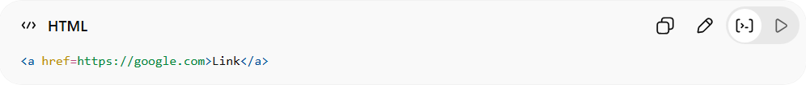
<a href=https://google.com>Link</a>
✅ Good:
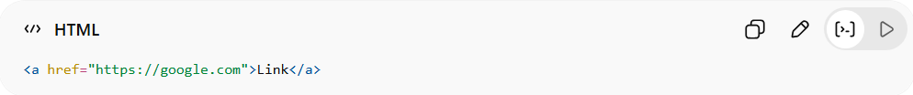
<a href="https://google.com">Link</a>

7. 📏 Clean Code
# Source: AI Source: Provided by: [Data Path: Persons Table -> ID Column: 1, Name_En Column: Motasem Essam] -> From: [ChatGPT] on [5/6/2026]
📖 Description:
Avoid unnecessary spaces and clutter.
❌ Bad:
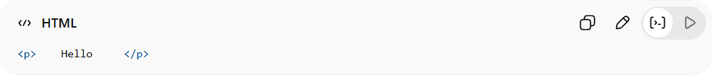
<p> Hello </p>
✅ Good:
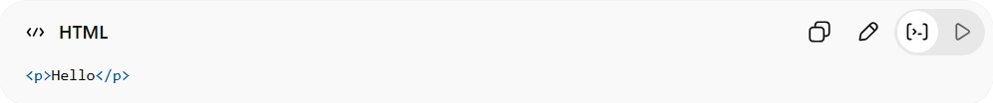
<p>Hello</p>

8. 🧭 One H1 Only
# Source: AI Source: Provided by: [Data Path: Persons Table -> ID Column: 1, Name_En Column: Motasem Essam] -> From: [ChatGPT] on [5/6/2026]
📖 Description:
Use only one <h1> as the main title.
❌ Bad:
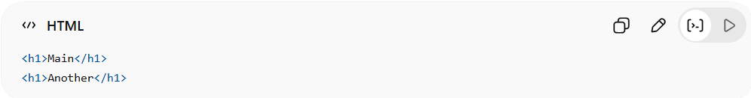
<h1>Main</h1>
<h1>Another</h1>
✅ Good:
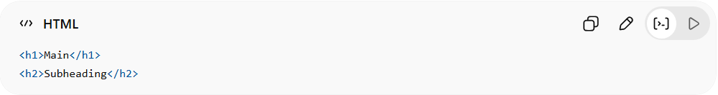
<h1>Main</h1>
<h2>Subheading</h2>

9. 🧱 Proper Nesting
# Source: AI Source: Provided by: [Data Path: Persons Table -> ID Column: 1, Name_En Column: Motasem Essam] -> From: [ChatGPT] on [5/6/2026]
📖 Description:
Tags must be correctly placed inside each other.
❌ Bad:
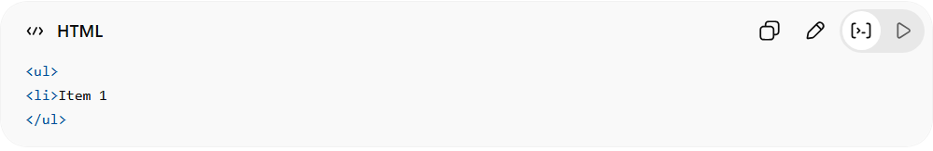
<ul>
<li>Item 1
</ul>
✅ Good:
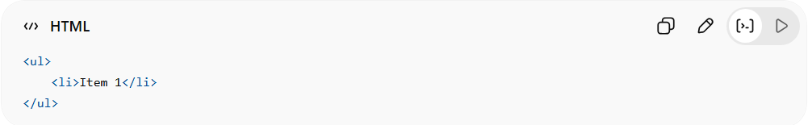
<ul>
<li>Item 1</li>
</ul>

10. 🖼️ ALT for Images
# Source: AI Source: Provided by: [Data Path: Persons Table -> ID Column: 1, Name_En Column: Motasem Essam] -> From: [ChatGPT] on [5/6/2026]
📖 Description:
Always describe images using alt.
❌ Bad:
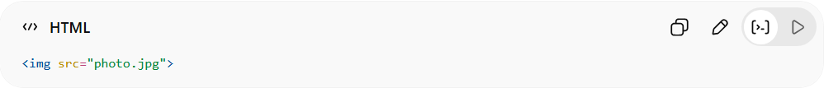
<img src="photo.jpg">
✅ Good:
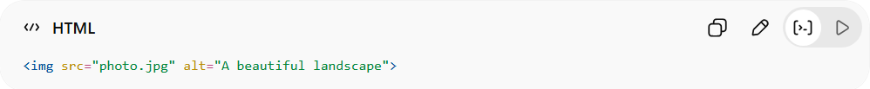
<img src="photo.jpg" alt="A beautiful landscape">

11. 📄 Document Structure
# Source: AI Source: Provided by: [Data Path: Persons Table -> ID Column: 1, Name_En Column: Motasem Essam] -> From: [ChatGPT] on [5/6/2026]
📖 Description:
Every HTML file should have the full structure.
❌ Bad:
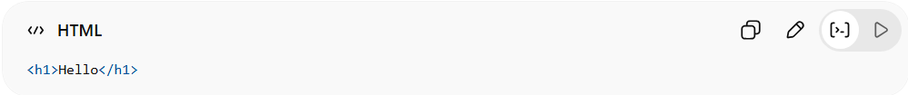
<h1>Hello</h1>
✅ Good:
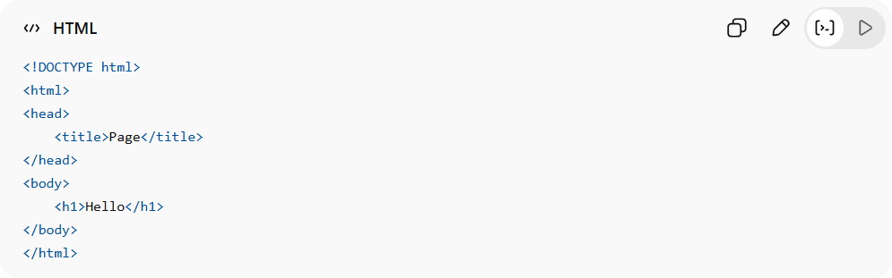
<!DOCTYPE html>
<html>
<head>
<title>Page</title>
</head>
<body>
<h1>Hello</h1>
</body>
</html>

12. ⚡ Avoid Inline Styles
# Source: AI Source: Provided by: [Data Path: Persons Table -> ID Column: 1, Name_En Column: Motasem Essam] -> From: [ChatGPT] on [5/6/2026]
📖 Description:
Do not mix design with HTML structure.
❌ Bad:
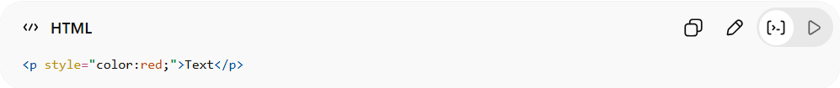
<p style="color:red;">Text</p>
✅ Good:
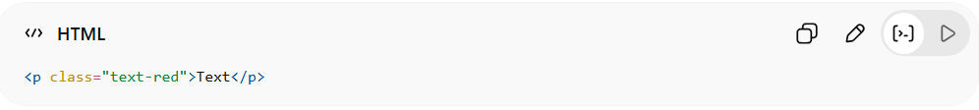
<p class="text-red">Text</p>

